**LAB 1**

**Ⅰ.Introduction**

In this lab, the general knowledgeable of ZigBee network and the hardware will be introduced, which is aim to familiar with ZigBee network and the software named Zena. And this lab divided into five parts: Introduce ZigBee, Introduce the hardware, Get familiar with the working environment, Learn how to use ZENA packet sniffer and Run the ZigBee demo.

**Ⅱ. Lab steps and results**

**Section 1. Introduction on ZigBee**

In this section, we looked into “ZigBee 2006 Application note (AN1232). By reading this note, we have got general information about ZigBee, such as ZigBee is a wireless protocol implemented in the wireless network with low data rate sensors. And it uses the IEEE 802.15.4 and has network formation, device address assignments, routing, messaging and device discovery functions.

**Section 2. Hardware**

For this step, we have learnt about the hardware of ZigBee. In this lab we used demo board (PIC24fj256 MCU) with RF module (MRF24j40) as ZigBee node, Pickit 3 to connect the Demo board with the PC, RS232 cable and Zena network analyzer.

**Section 3. Working environment**

In this section, we built the demo applications by following the steps of lab notes and connected devices with PC.

**Section 4. Zena network sniffer**

We did every single steps of section 4 that is shown in QuickStartGuide and changed the channel to our group number 22. The result is shown below:

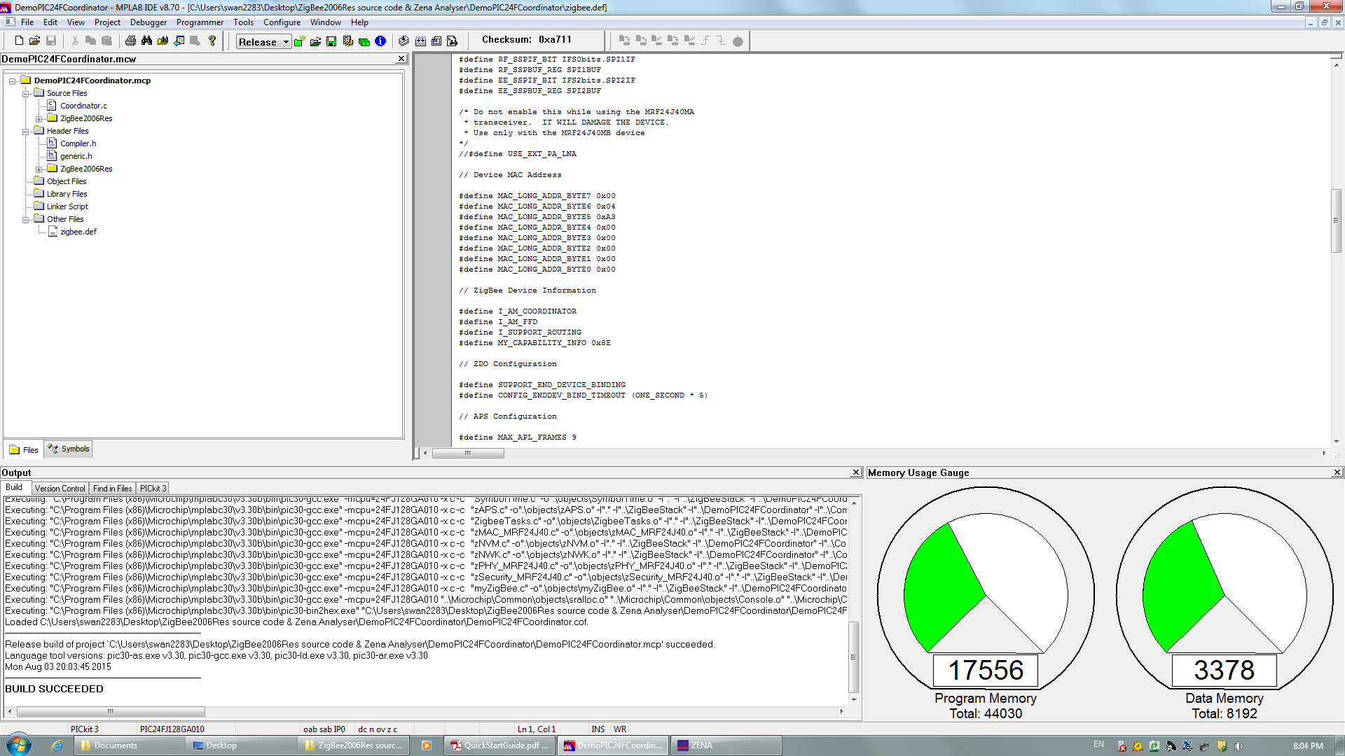

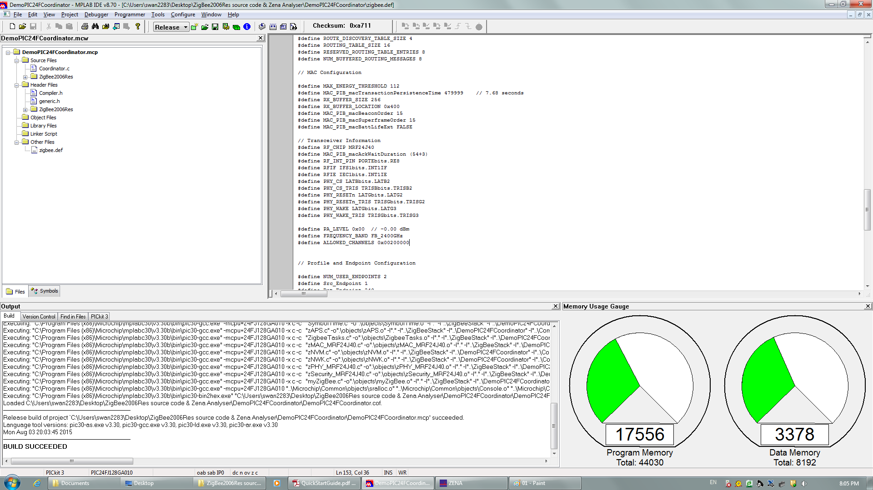

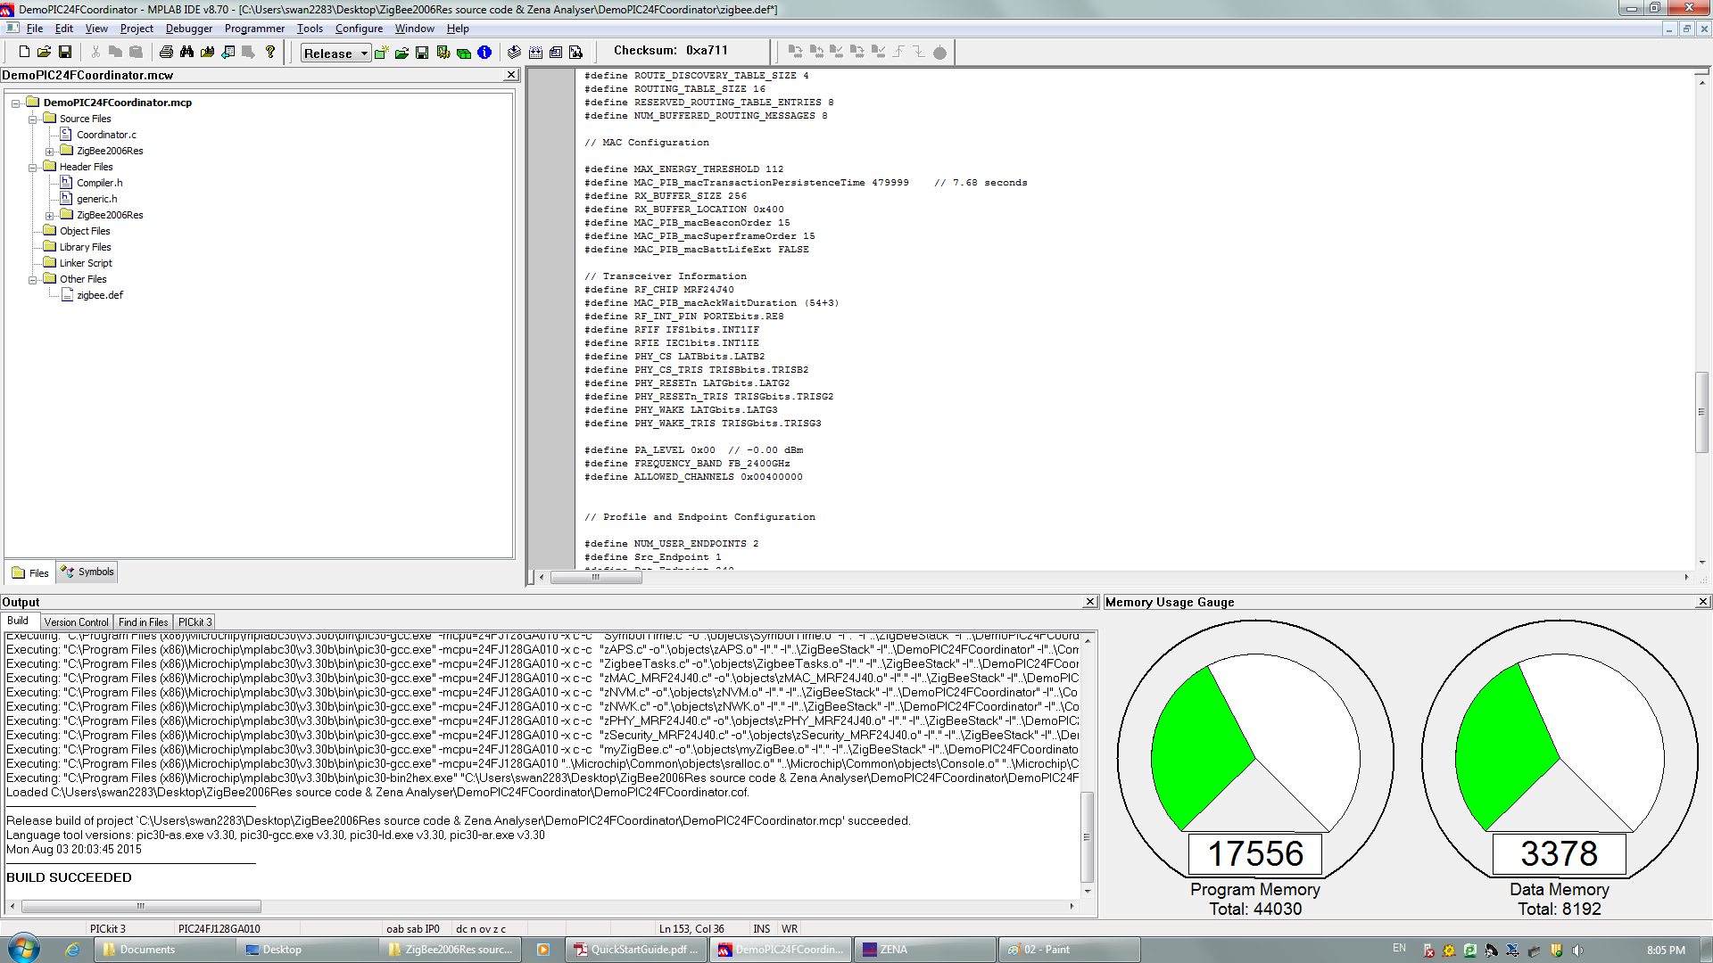

And the network topology is:

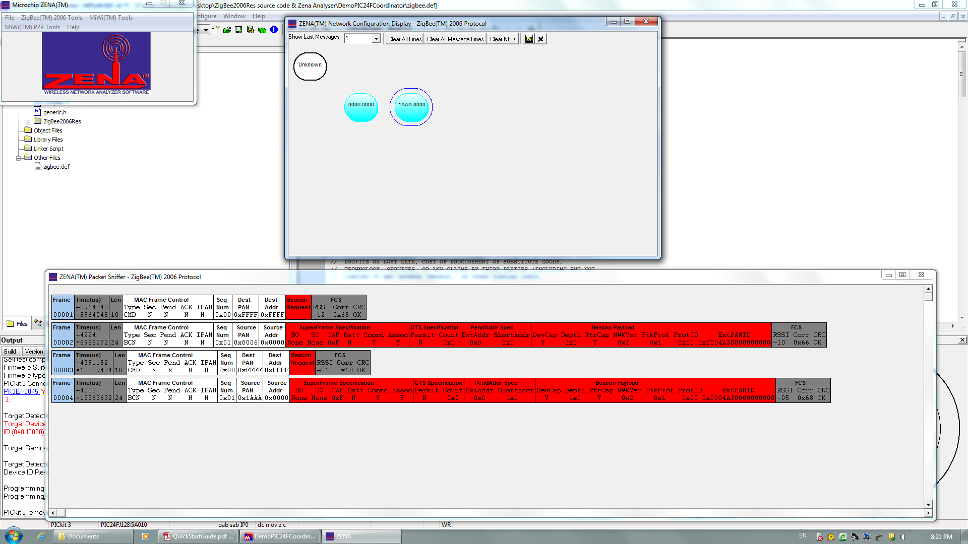

**Section 5. Run the ZigBee demo**

Firstly, we programed two devices, coordinator and one router. Then switch the device power off. And connected a RS-232 cable from the coordinator device to the PC. Finally, opened up a Putty window on the PC to the COM port.

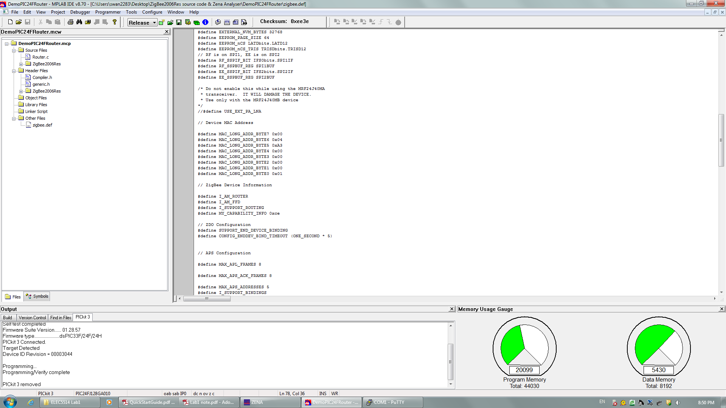

Hit the ‘Enter’, the menu system showed as below:

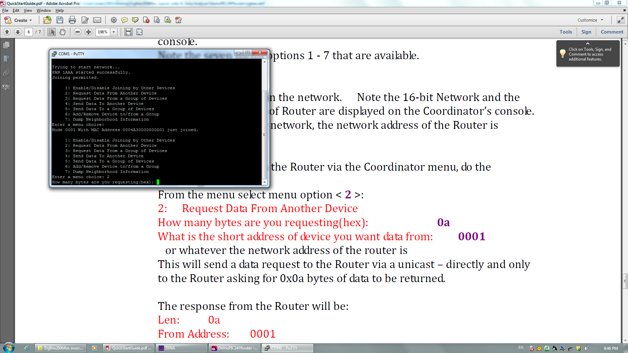

Then we typed 2 in the menu, the figure below shows the result:

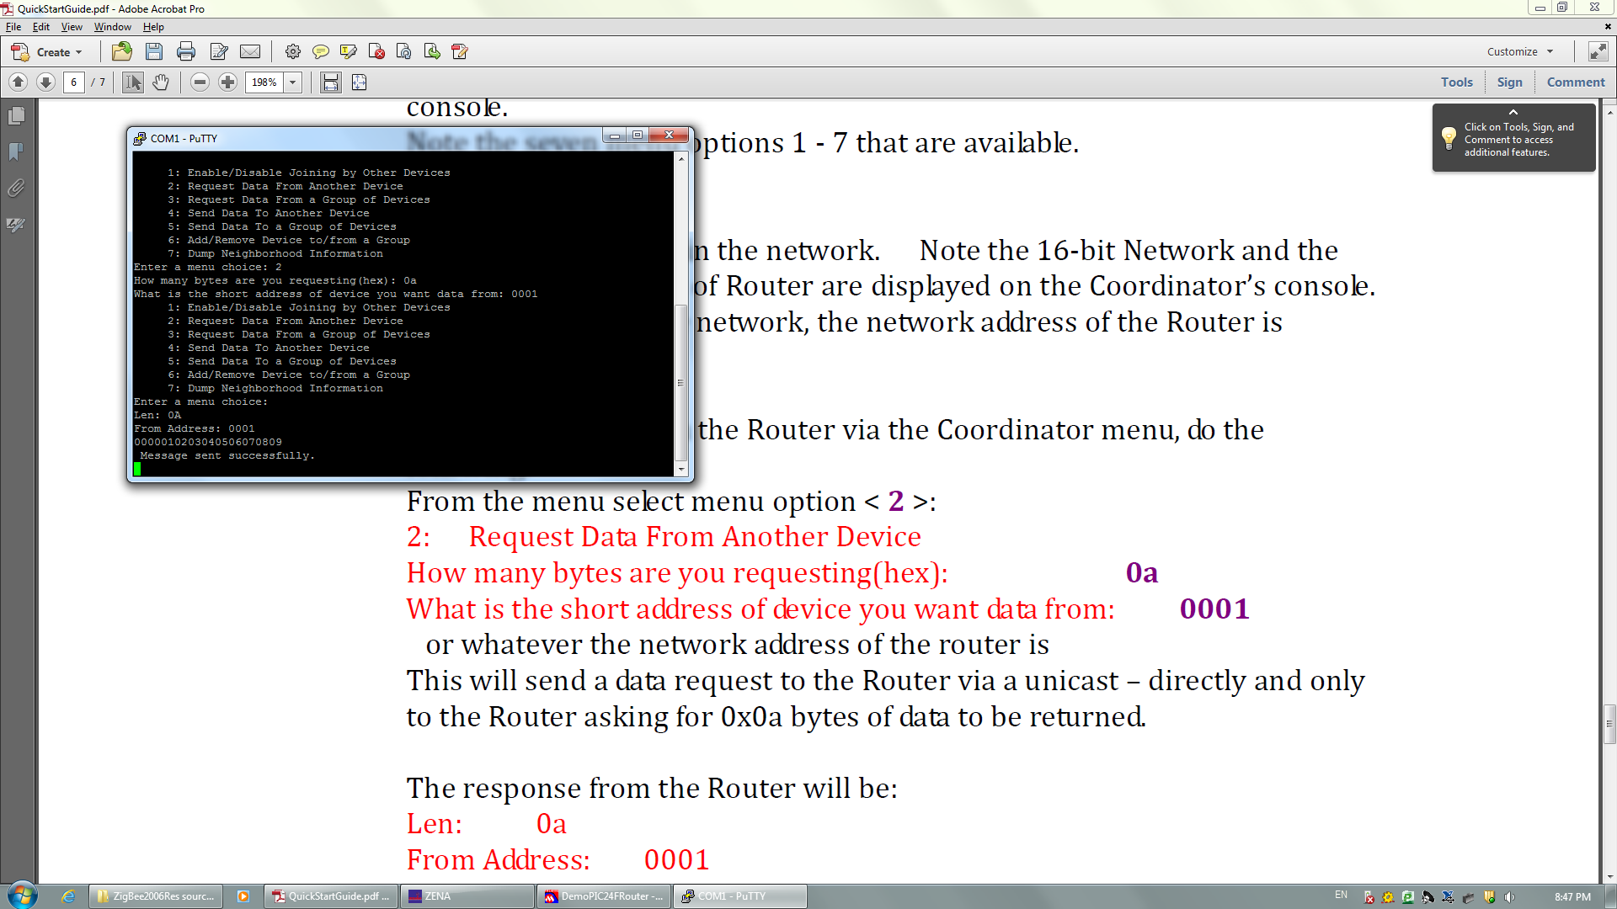

Then select option 4, the result is:

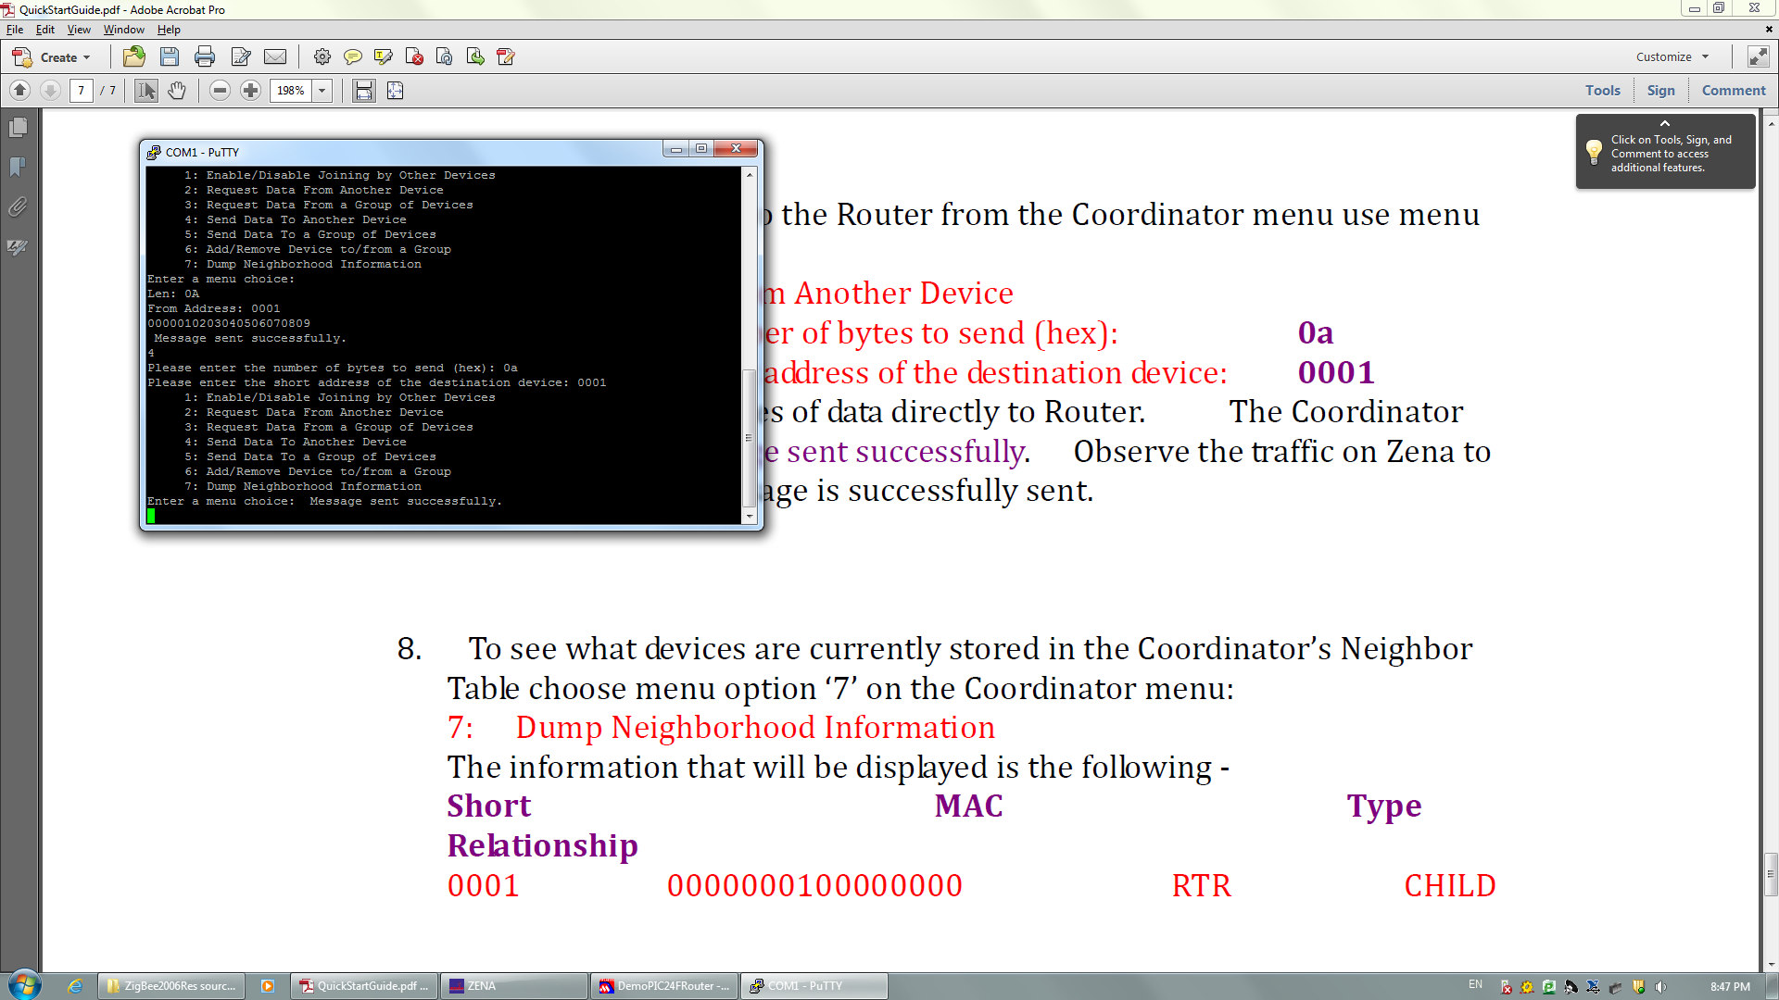

The result of option 7 is shows as below:

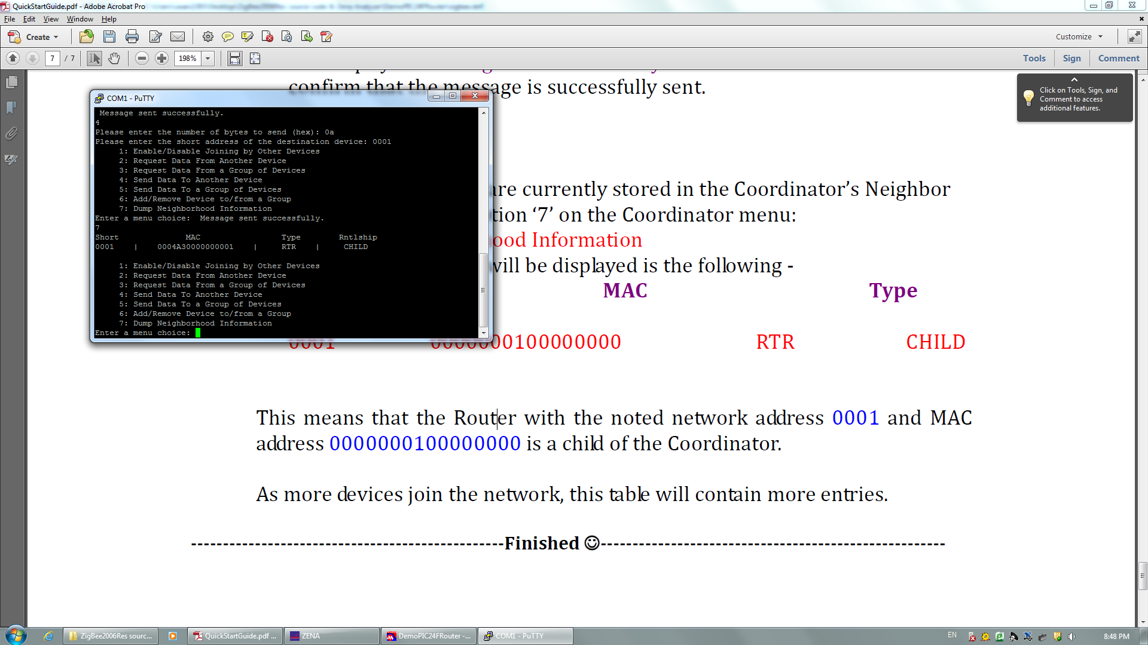

**Ⅲ. Conclusion**

In this lab, we have learnt the general knowledgeable of ZigBee network and the hardware of this system, and got familiar with the working environment, learnt how to use ZENA packet sniffer. Also, the demo code was understood.